SETTING POETRY PROJECT
Using Ted Kooser’s “Abandoned Farmhouse” as your mentor text, you will create a project representing your personality through a setting where you can often be found. Follow the instructions below.
Step 1: Folding
- Fold a piece of computer paper horizontally (“hamburger style”).
- Make a vertical TRIFOLD (fold into 3 equal sections).
- Unfold the trifold and “dog ear” the top left and top right corner of the paper.
- Unfold the “dog ears” and push them down/inside the foldable so you now see a hexagon shape.
- Take the top layer of the hexagon and fold the right side into the middle, then the left side into the middle.
Step 2: Design Front of Setting
On the front/outside of the foldable, create a personal “setting” which reflects a place where you may be found.
- Examples: The outside of a house, a car, a library, a tent, a sporting stadium, a farm, a lake, the beach, the woods, the mall, etc.
Step 3: Design Inside of Setting
Inside the opening of the front folds, design the smaller setting within the larger one on the front.
- Examples: A bedroom inside a house, the interior of a car, a table in a library, the inside of a tent, etc.
Step 4: Write Poem Inside
On the deep inside of this “setting” (open your paper all the way), you will create a description of the setting and how it relates to you and your interests.
- Option of Poem Format: This may be done in poetic format modeled after Ted Kooser’s “Abandoned Farmhouse,” or you may use a different poetic format of your choice.
- Content: Your use of words and diction are important. The reader should be able to identify your tone and attitude toward your topic (your setting).

Criteria for Grading
Outside:
- Artwork is colorful, neat, appropriate, and effective. ______/15 pts.
- Format is followed, with both exterior and interior represented. ______/15 pts.
Inside:
- A title is included on poem ______/5 pts.
- Typed or neatly handwritten or printed in blue or black ink ______/5 pts.
- Poetic format (lines and stanzas) and devices are used ______/10 pts.
- Reveals information about your setting ______/20 pts.
- Explains how the setting reveals your interests and personality ______/20 pts.
- Proofreading is evident ______/10 pts.
Abandoned Farmhouse
By Ted Kooser
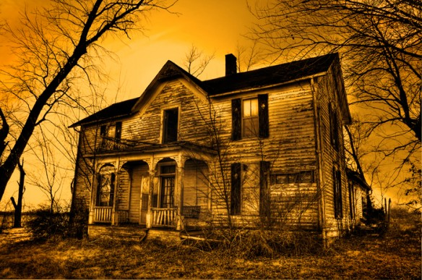
He was a big man, says the size of his shoe
on a pile of broken dishes by the house;
a tall man too, says the length of the bed
in an upstairs room; and a good, God-fearing man,
says the Bible with a broken back
on the floor below the window, dusty with sun;
but not a man for farming, say the fields
cluttered with boulders and the leaky barn.
A woman lived with him, says the bedroom wall
papered with lilacs and the kitchen shelves
covered with oilcloth, and they had a child,
says the sandbox made from a tractor tire.
Money was scarce, say the jars of plum preserves
and canned tomatoes sealed in the cellar hole.
And the winters cold, say the rags in the window frames.
It was lonely here, says the narrow country road.
Something went wrong, says the empty house
in the weed-choked yard. Stones in the fields
say he was not a farmer; the still-sealed jars
in the cellar say she left in a nervous haste.
And the child? Its toys are strewn in the yard
like branches after a storm-a rubber cow,
a rusty tractor with a broken plow,
a doll in overalls. Something went wrong, they say.

